III. Proposed Research Methodology

The goal of our examination is to build up an Augmented Reality and hand gesture-based application for learning 3D geometry. This paper expects to show a uniqueapproach for successful learning 3D geometry for preliminary school going children. At the end of the day, it endeavors to furnish understudies with a simple and an advantageous method to probably learn 3D geometry. As mentioned before, this paper does not propose a new method, instead it proposed a modified method called “Modified Extrusion Technique”.

The method essentially centered around two principle innovations Augmented Reality and hand gesture acknowledgment to develop a hands-on learning technique for the learner. With Augmented Reality, the learners can comprehend the fundamental ideas of 3D geometrical shapes, their connections and approaches to build the 3D shapes and the items in 3D space. Vitally, Augmented Reality can give a dynamic representation of 3D structures of geometrical shapes. This element causes the students to comprehend a complete foundation of 3D geometrical shapes and enhance the capacities of geometrical structures. In addition, the hand gesture-based connections outfit an instinctive and advantageous path for the understudies to specifically control and cooperate with geometrical shapes in 3D space. With the encounters of interfacing with the 3D shapes utilizing their own hand motions, the understudies can enhance their very own consciousness of the connections of the 3D shapes and effectively recollect or hold the learning about the 3D shapes.

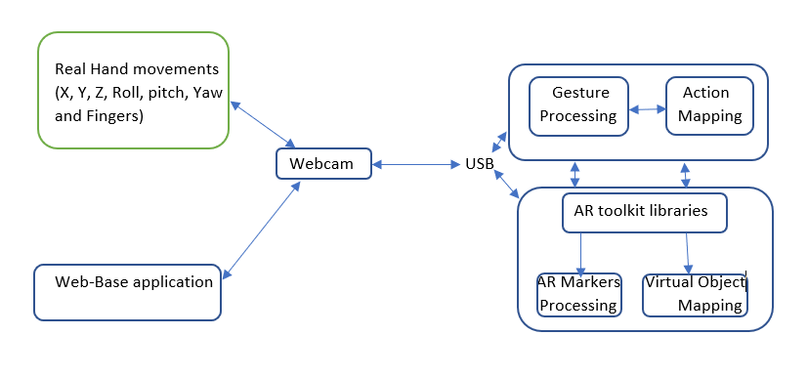

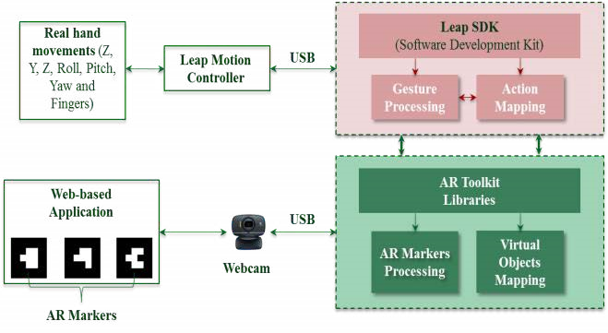

1. (b)

Fig.2. (a)Extrusion Technique [16] and (b) Modified Extrusion Technique Architecture

Architectural overview of the proposed system is shown in Fig. 2. The proposed system deals with dynamic hand gesture recognition, so this is a real time system. Various types of posture are enlisted for recognition, but firstly, only worked with the numbers of fingers to testify that whether the system can recognize hand or not. The system will visualize through a basic webcam to recognize the hand and hand gesture. Than it will bound the hand and extract the hand from other parts of body as the skin types are quite similar for hands and other parts of body. The student can visualize the geometry shape both in 2D and 3D with the assist of AR markers. Than the AR marker is obtained by the webcam. During the hand gesture recognition and the AR marker recognition, in both cases a webcam is used while the AR Toolkit libraries overlays and displays exactly the 3D virtual objects on those physical AR markers in the AR environment. Whenever the students or the teacher will try to interact the augmented shape, it will map the gesture and will produce pre-built geometrical shape in the augmented environment.

**Recognition Using EmguCV:**

1. Step 1: Gesture Processing

Recognition process starts with hand gesture recognition. User or the learner have to be available before the webcam that is installed on the personal laptop or computer. User can do move like raising finger starting from one to ten. They also can show their thumb finger according to the given posture at fig. 11. Hand gesture is recognized through the webcam. A series of hand-written code is used to recognize the hand gesture. The code is segmented is YCrCb skin detection, skin color detection and HSV skin color detection. YCbCr is a commonly used color space in digital video domain. Because the representation makes it easy to get rid of some redundant color information, it is used in image and video compression standards like JPEG, MPEG1, MPEG2 and MPEG4. In this format, luminance information is stored as a single component, and chrominance information is stored as two color-difference components (Cb and Cr). Cb represents the difference between the blue component and reference value. Cr represents the difference between the red component and a reference value. Skin Color detection deals with the recognition of skin-colored pixels and regions in a given image. Skin color is often used in human skin detection because it is invariant to orientation and size and is fast to process. The three main parameters for recognizing a skin pixel are RGB (Red, Green, Blue), HSV (Hue, Saturation, Value) and YCbCr (Luminance, Chrominance) color models. The HSV color space is more intuitive to how people experience color than the RGB color space. As hue (H) varies from 0 to 1.0, the corresponding colors vary from red, through yellow, green, cyan, blue, and magenta, back to red. As saturation(S) varies from 0 to 1.0, the corresponding colors (hues) vary from unsaturated (shades of gray) to fully saturated (no white component). As value (V), or brightness, varies from 0 to 1.0, the corresponding colors become increasingly brighter. The hue component in HSV is in the range 0° to 360° angle all lying around a hexagon. The main reason of the code segmentation is to recognize the hand fully. Because, there could be any kind of disturbance like same color things, other parts of the body. So, despite all these problems the problems the code can segment the hand fully and can recognize the gesture.

1. Step 2: Action Mapping

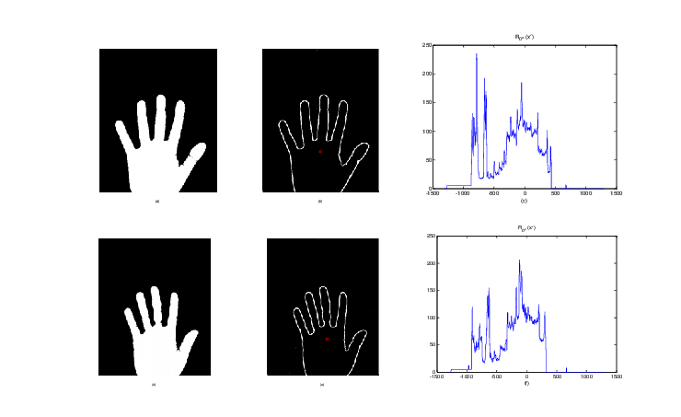

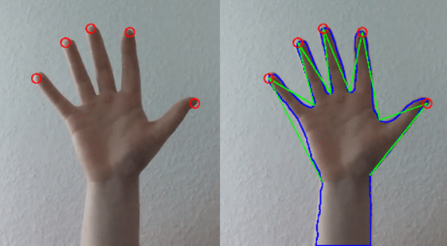

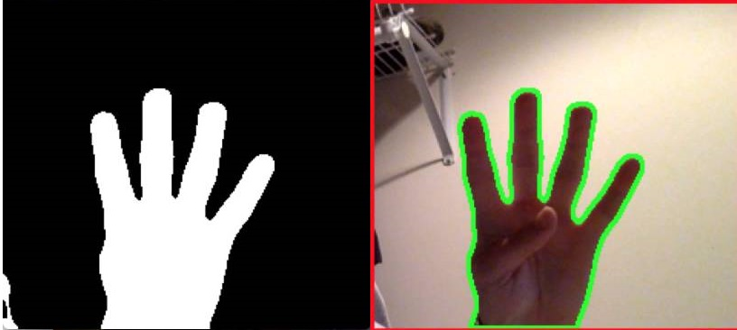

(a) (b) (c)

Fig. 3. (a)Binary Normalization (b) Morphological extraction (c)Background Subtraction

Action mapping starts with the ending of skin detection. The first step is generating a three-dimensional image space which is obtained by the two-dimensional binary image normalization.Than the background is subtracted using the median value applying a threshold in the color spaceat the end a morphological image is extracted.Morphological image processing is a collection of non-linear operations related to the shape or morphology of features in an image. According to Wikipedia, morphological operations rely only on the relative ordering of pixel values, not on their numerical values, and therefore are especially suited to the processing of binary images. Morphological operations can also be applied to greyscale images such that their light transfer functions are unknown and therefore their absolute pixel values are of no or minor interest.Morphological techniques probe an image with a small shape or template called a structuring element. The structuring element is positioned at all possible locations in the image and it is compared with the corresponding neighborhood of pixels. Some operations test whether the element "fits" within the neighborhood, while others test whether it "hits" or intersects the neighborhood Than the action is mapped to a pre-defined model or dataset and the output is shown in the ImageBoxAdvanced gesture mapping methods can be used to manage a variety of gesture conflicts and gesture ambiguities, such as: pose ambiguity from tracking errors due to motion blur, hand self-occlusion or pose confusion from similarity and user error. When working with rich gestures (where high degrees of freedom are available) there is a greater chance of variability in the performance of gestures from one user to another. This is especially true of 3D motion gestures as there are fewer physical constraints on motion or pose, unlike surface touch gestures which limit motion to the plane of the 2D surface or hand-held gamepad controllers with mechanical buttons that limit motion. As a result, there is greater variation in user-performed actions (poses and motion) within bare-hand motion gestures.

**Recognition Using OpenCV**

OpenCV (Open Source Computer Vision Library) is a library of programming functions mainly aimed at real-time computer vision. Originally developed by Intel, it was later supported by Willow Garage then Itseez. It has C++, Python and Java interfaces and supports Windows, Linux, Mac OS, iOS and Android. We use python as programming language.

1. Step 1: Process image

At first in the program define region of interest, skin color in HSV. It then applies *GaussianBlur* openCV function for python to smooth the image. The function convolves the source image with the specified Gaussian kernel. Then it finds contour with maximum area and creates bounding rectangle around the contour to find convex hull and convexity defects. And then it shows the required images.

1. Step 2: Detect Hand Action

When hand come in the target region, it find the defects due to figures. Suppose there are zero defect on one finger, one defect between two fingers, two defects between three fingers,three defects between four fingers and four defects between five fingers,. So after detect the defect count program show the correspondence output on frame using openCV *putText* function in python.

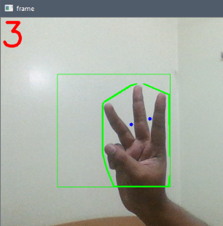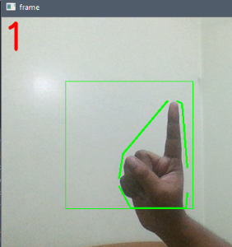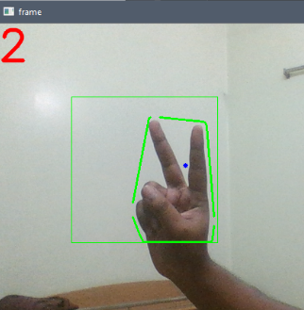

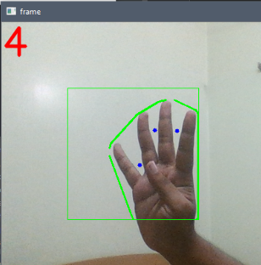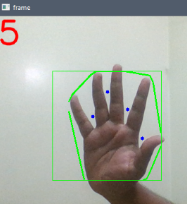

Fig. 4. 0 blue Dot in 1,one blue Dot in 2,two blue Dot in 3,three blue Dot in 4,four blue Dot in 5.(blue dot indicate the defect between fingers)

References:

[1] Kaufrmann, Hames and Schmalstieg, Dieter, “Mathematics and Geometry Education with Collaboration Augmented Reality”, Computers & Graphics, vol. 27, issue 3, June 2003, pages 339-345. Accessed at: https://doi.org/10.1016/S0097-8493 (03)00028-1.

[2] Azad et al. (2018), “Dynamic 3D hand gesture recognition by learning weighted Depth motions”, IEEE Transactions on Circuits and Systems for Video Technology, doi:10.1109/TCSVT.2018.2855416, Accessed at: https://ieeexplore.ieee.org/document/8410578.

[3] Chen et al. (2017), “A hybrid CNN-SVM classifier for hand gesture recognition with surface EMG signals”, 2018 International Conference on Machine Learning and Cybernetics doi:10.1109/ICMLC.2018.8526976.

[4] Jung et al. (2017), “Boosthand: Distance-free object manipulation system with switchable non-linear mapping for augmented reality classrooms”, [2017 IEEE International Symposium on Mixed and Augmented Reality (ISMAR-Adjunct)](https://ieeexplore.ieee.org/xpl/mostRecentIssue.jsp?punumber=8087877). doi: 10.1109/ISMAR-Adjunct.2017.96

[5] M.I.N.P. Munasinghev, “Dynamic hand gesture recognition using computer vision and neural networks”, 2018 3rd International Conference for Convergence in Technology (I2CT). doi: 10.1109/I2CT.2018.8529335

[6] Alam et al. (2018), “Improved gesture recognition using deep neural network on sEMG”, 2018 International Conference on Engineering, Applied Sciences, and Technology (ICEAST) doi:10.1109/ICEAST.2018.8434493.

[7] Alani et al. (2018), “Trajectory based hand gesture recognition using Kinect via deterministic learning”, 2018 37th Chinese Control Conference (CCC). doi:10.23919/ChiCC.2018.8482621

[8] Rani et al. (2017), “Hand gesture control of virtual object in augmented reality”, **2017** International Conference on Advances in Computing, Communications and Informatics (ICACCI). doi:10.1109/ICACCI.2017.8126053.

[9] Krupaka et al. (2017), “Toward realistic hand gesture interface: keeping it simple for developers and machine”.

CHI '17 Proceedings of the 2017 CHI Conference on Human Factors in Computing Systems Pages 1887-1898.  
doi:10.1145/3025453.3025508

[10] Chiang et al. (2017). 3D depth information based 2D low complexity hand posture and gesture recognition design for human computer interaction. Accessed at: <https://ieeexplore.ieee.org/abstract> /document/8463327, November, 2018.

[11] Krittameth et al. (2018), “Hand Gesture Recognition with inertial sensors”, 2018 40th Annual International Conference of the IEEE Engineering in Medicine and Biology Society (EMBC). doi:10.1109/EMBC.2018.8513098

[12] Kui Liu (2014), “Fusion of inertial and depth sensor data for Robust hand gesture recognition”,IEEE Sensors Journal ( Volume: 14 , Issue: 6 , June 2014 ).

doi:10.1109/JSEN.2014.2306094

[13] Liu et al. (2014), “Multi HMM classification for hand gesture recognition using two different modality sensors”, 2014 IEEE Dallas Circuits and Systems Conference (DCAS). doi:10.1109/DCAS.2014.6965338.

[14] Gudavalli et al. (2018), “Hand gesture recognition based on cascading of multiple feature”. 2018 International Conference on Intelligent Autonomous Systems (ICoIAS). doi:10.1109/ICoIAS.2018.8493816.

[15] Oka et al. (2002), “Real-time fingertips tracking and gesture recognition”,**IEEE** Computer Graphics and Applications (Volume: 22, Issue: 6 , Nov/Dec 2002 ) .**doi:**10.1109/MCG.2002.1046630

[16]. Hong-Quan Le, Jee-In Kim,“An Augmented Reality Application with Hand Gestures for Learning 3D Geometry”. 2017 IEEE International Conference on Big Data and Smart Computing (BigComp). doi:10.1109/BIGCOMP.2017.7881712

[17]. Meiping Tao, Li Ma, “A Hand Gesture Recognition Model Based on Semi-supervised Learning”, 2015 7th International Conference on Intelligent Human-Machine Systems and Cybernetics, doi:10.1109/IHMSC.2015.230

[18].DeviraAnggi Maharani, HanifFakhrurroja, Riyanto, CarmadiMachbub, “Hand Gesture Recognition Using K-Means Clustering and Support Vector Machine”, **2018** IEEE Symposium on Computer Applications & Industrial Electronics (ISCAIE), doi:10.1109/ISCAIE.2018.8405435.

[19]. D.K. Vishwakarma, Sahib Majithia, [Nikhil Kumar Mishra](https://ieeexplore.ieee.org/search/searchresult.jsp?searchWithin=%22First%20Name%22:%22Nikhil%20Kumar%22&searchWithin=%22Last%20Name%22:%22Mishra%22&newsearch=true&sortType=newest), “A Static Hand Gesture Recognition System to Recognize the Total number of Fingers”, 2017 International Conference on Recent Innovations in Signal processing and Embedded Systems (RISE). doi:10.1109/RISE.2017.8378176

[20] TanatchaChaikhumpha,PhattanaphongChomphuwiset , “Real – time Two Hand Gesture Recognition with Condensation and Hidden Markov Models”, 2018 International Workshop on Advanced Image Technology (IWAIT). doi:10.1109/IWAIT.2018.8369811

[21] Fan Zhang, Yue Liu, ChunyuZou, Yongtian Wang, “Hand gesture recognition based on HOG-LBP feature”, 2018 IEEE International Instrumentation and Measurement Technology Conference (I2MTC). **doi:**10.1109/I2MTC.2018.8409816

[22]. Ali A. Alani, Georgina Cosma, AboozarTaherkhani ,T.M McGinnity,“Hand Gesture Recognition Using an Adapted Convolutional Neural Network with Data Augmentation”.2018 4th International Conference on Information Management (ICIM). doi:10.1109/INFOMAN.2018.8392660

[23]. [Dinesh Kumar Vishwakarma](https://ieeexplore.ieee.org/search/searchresult.jsp?searchWithin=%22First%20Name%22:%22Dinesh%20Kumar%22&searchWithin=%22Last%20Name%22:%22Vishwakarma%22&newsearch=true&sortType=newest),“Hand Gesture Recognition using Shape and Texture evidences in Complex Background”, 2017 International Conference on Inventive Computing and Informatics (ICICI). doi:10.1109/ICICI.2017.8365354

[24] P. N. V. S. Gowtham, “A Hand Gesture Recognition Based Virtual Touch Wall”, IJIET 2012 Vol.2 (1): 36-42 ISSN: 2010-3689. doi:10.7763/IJIET. 2012.V2.7

[25]. Pichao Wang1, Wanqing Li1, Song Liu1, Zhimin Gao1, Chang Tang2 and Philip Ogunbona1 “Large-scale Isolated Gesture Recognition Using Convolutional Neural Networks”, 2016 23rd International Conference on Pattern Recognition (ICPR). doi:10.1109/ICPR.2016.7899599

[26]. M. Yeasin, S. Chaudhuri, “Dynamic hand gesture understanding - a new approach”, 1999 IEEE International Conference on Acoustics, Speech, and Signal Processing. Proceedings. ICASSP99 (Cat. No.99CH36258). doi:10.1109/ICASSP.1999.757490

[27].Yunan Li , Qiguang Miao, KuanTian, Yingying Fan, XinXu, RuiLi,Jianfeng Song , “Large-scale Gesture Recognition with a Fusion of RGB-D Data Based on the C3D model”, 2016 23rd International Conference on Pattern Recognition (ICPR), doi:10.1109/ICPR.2016.7899602

[28]. Ryan Christopher Yeoh,StevenZhiYing Zhou , “Consistent Real-time Lighting for Virtual Objects in Augmented Reality”. 2009 8th IEEE International Symposium on Mixed and Augmented Reality, doi:10.1109/ISMAR.2009.5336453

[29]. HartmutSeichter, “SKETCHAND+ a collaborative augmented reality sketching application”,Accessed at: <https://www.researchgate.net/publication/30874877_Sketchand_a_Collaborative_Augmented_Reality_Sketching_Application>

[30]. Tiffany Leung, FarhanaZulkernine, HarunaIsah, “The use of Virtual Reality in Enhancing Interdisciplinary Research and Education”, Accessed at: https://arxiv.org/abs/1809.08585

[31]. A. Butz T. Hollerer,S.Feiner, B. MacIntyre,C. Beshers , “Enveloping Users and Computers in a Collaborative 3D Augmented Reality”, Proceedings 2nd IEEE and ACM International Workshop on Augmented Reality (IWAR'99), doi:10.1109/IWAR.1999.803804

[32]. James Purnama, Daniel Andrew, MaulahikmahGalinium , “Geometry Learning Tool for Elementary School using Augmented Reality”, 2014 International Conference on Industrial Automation, Information and Communications Technology, doi:10.1109/IAICT.2014.6922112

[33]. H. Kaufmann, D. Schmalstieg, “Designing Immersive Virtual Reality for Geometry Education”, IEEE Virtual Reality Conference (VR 2006), doi:10.1109/VR.2006.48

[34]. [Hannes Kaufmann](https://www.researchgate.net/profile/Hannes_Kaufmann), Karin Steinbügl, “Improving Spatial Abilities by Geometry Education in Augmented Reality - Application and Evaluation Design”, Accessed at: https://www.researchgate.net/publication/216867616_Improving_Spatial_Abilities_by_Geometry_Education_in_Augmented_Reality_Application_and_Evaluation_Design_Proceedings.

[35]. Hannes Kaufmann, “The potential of augmented reality in dynamic geometry education”, Accessed at: https://www.researchgate.net/publication/228350641_The_potential_of_augmented_reality_in_dynamic_geometry_education.

[36].HannesKaufmann, DieterSchmalstieg, “Mathematics and Geometry Education with Collaborative Augmented Reality”, Accessed at: https://doi.org/10.1016/S0097-8493 (03)00028-1

[38] Manavender R. Malgireddy, “A Framework for Hand Gesture Recognition and Spotting Using Sub-Gesture Modeling”, https://ieeexplore.ieee.org/document/5597566/

[39] Fan Zhang, “Hand gesture recognition based on HOG-LBP feature”,2018 IEEE International Instrumentation and Measurement Technology Conference (I2MTC),doi: 10.1109/I2MTC.2018.8409816

[40] Dinesh Kumar Vishwakarma, Hand Gesture Recognition in Low-Intensity Environment Using Depth Images [2017 International Conference on Intelligent Sustainable Systems (ICISS)](https://ieeexplore.ieee.org/xpl/mostRecentIssue.jsp?punumber=8376163),doi:10.1109/ISS1.2017.8389446

[41]NUSHandPostureDataset,https://www.ece.nus.edu.sg/stfpa ge/elepv/NUS-HandSet. University Science, 1989.

[42]Barczak, A.L.C.,Reyes, N.H.,Abastillas, M.,Piccio, A.,Susnjak, T.,“A new 2D static hand gesture colour image dataset for ASL gestures”, Massey University, Accessed at : http://hdl.handle.net/10179/4514

[43] MarimpisAvraam, “Static Gesture Recognition Combining Graph and Appearance Features’’, International Journal of Advanced Research in Artificial Intelligence (IJARAI), Volume 3 Issue 2, 2014. doi: 10.14569/IJARAI.2014.030201

[44]."Emgu CV". (2019, January 23). Retrieved from<http://www.emgu.com/wiki/index.php/Main_Page>.

[45]."OpenCV". (2019, January 23). Retrieved from https://opencv.org.

[46]."NumPy". (2019, January 23). Retrieved from<http://www.numpy.org>.